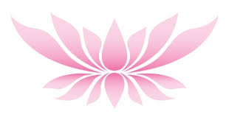
Lindsey Phillips Beauty Therapy
0426 845 197
www.lindseyphillipsbeautytherapy.com

Hello Karleigh
Thank you for registering for your half price massage or facial.
Choose from either
One Hour Massage for $30 (normally $60)
Or
Luxury Facial for $30.00 (normally $60)
Call to make an appointment and mention this offer.
Looking forward to seeing you soon at Lindsey Phillips Beauty Therapy.

